Fuel Consumption/Economy Trends in LAS countries:
The Moroccan Case Study

Author
Amr El-Abyad
Contributors
Hossam Allam
Matthias Gasnier

Nov 2014

Draft Version 1.0

Center for Environment and Development for the Arab Region and Europe (CEDARE)

Table of Contents
1 Introduction. 2
1.1 Objectives 2
1.2 Approach 2
1.3 Limitations 4
2 Background information 5
2.1 Fuel Economy 5
2.2 Factors Affecting Fuel/Consumption Economy 5
2.3 Fuel Economy Standards 7
2.4 Driving Cycles 8
3 Morocco in a North African context 9
4 LDVs Policy Environment in Morocco 11
5 Data for CO₂ Emissions and Fuel consumption in Morocco 12
6 Discussion of Data 15
7 Way Forward and Recommendations 18

List of Figures
Figure 1: Total Vehicles on the road. (OICA 2014) 10
Figure 2: Sales of new LDVs in Tunisia and Egypt. (Matthias Gasnier 2014) 10
Figure 3: Sales of new LDVs in Morocco. (Matthias Gasnier 2014) 10
Figure 4: Different Averages for CO2 emission in Morocco 13
Figure 5: Different Averages for diesel CO2 emissions in Morocco 13
Figure 6: Petrol Fuel Consumption for LDVs in Morocco 14
Figure 7: Diesel Fuel Consumption for LDVs in Morocco 15
Figure 8: The evolution of co2 emissions from Transportation in Morocco 19

Introduction.
The transport sector is responsible for 27 % of the world energy consumption (IEA, 2012). This proportion has increased from 23% in 1973 (IEA, 2011) and contributes to 22 % of total CO₂ emissions (IEA, 2012).
A growing international concern over climate change induced by the burning of fossil fuels has been accelerating. Also the security and sustainability of oil supplies are subject of growing global concerns. In response to those challenges many countries all over the world are working on curbing oil consumption and finding alternative resources. That’s why many countries worldwide have introduced fuel consumption/ economy or CO₂ emissions standards towards the end of improving vehicles energy efficiency. A number of initiatives around the world have been introduced to help countries with regard to fuel efficiency/ economy standards. The Global Fuel Economy Initiative (GFEI) comes as an effort of five organizations to promote improvements in vehicle fuel economy. This initiative aims to achieve 50 % improvements by 2050 in all vehicles globally compared to that in the year 2005. The initiative’s main activities include: data development and analysis, policy support, and awareness raising (GFEI, 2013).

Objectives
In line with the United Nations Environmental Program (UNEP) work on promoting sustainability and the GFEI’s efforts in prompting the introduction of more energy efficient vehicles, this report comes as part of sequel aiming to analyze the status and trends of fuel consumption/economy standards in at least four Arab countries as the region still lacks fuel consumption/economy standards. This report presents an analysis of the Moroccan case study and eventually comes out with a discussion on how to improve the fuel consumption/economy performance of the Moroccan LDVs fleet with the associated recommendations.

Approach
The report is about the trend patterns in fuel consumption/economy and CO₂ emissions. It views the status of emissions and fuel consumption through the lens of changing weighted averages for new Light Duty Vehicles (LDVs) for the years 2009, 2012 and 2013. Thus the report provides a sense of changing state of emissions and Fuel consumption in Morocco.
Accordingly, figures for sales of new Light Duty vehicles have been obtained along with the official figures for CO₂ emissions and fuel consumption for almost all the models. Figures for total LDVs on the road for the study years have also been obtained to put the trends in perspective and to feed into the report’s discussion on improving fuel consumption/economy and the associated recommendations.
Figures for new LDVs sales in 2009, 2012 and 2013 have been obtained from manufacturers and were collected by an automotive markets consultant, Matthias Gasnier. For reliability, the figures were cross-checked with sample figures for new LDVS sales from IHS consulting as well as total figures of different model sales in Tunisia obtained from the International Organization of Motor Vehicle Manufacturers (OICA). Further, figures obtained from the Egyptian Manufacturers Information Council (AMIC) were used as well in cross-checking. Data are classified by Vehicle’s make; model; fuel type and engine size.
Manufacturers’ specifications manual and compilations of the French Environment and Energy Management Agency (Ademe) have been used to arrive at the manufacturers’ labeled figures for fuel consumption/economy and CO₂ emissions. Then GFEI methodology (GFEI, 2014) has been used in calculating the weighted harmonic average annual fuel consumption/economy, and the weighted average annual CO₂ emissions:
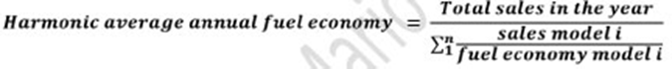

The definition of the GFEI for LDVs has been used in deciding on the vehicles to be included in the report study (GFEI, 2014). The definition is as follows:

Table 1: The GFEI definition of LDVs
Vehicle Segment | Examples
A: Mini / Micro / Small town car  Smallest cars, with a length between 2.50m to 3.60m. | Citroën C1  Fiat Panda  Smart Fortwo
B: Small compact  Slightly more powerful than the Minis; still primarily for urban use; length between 3.60m and 4.05m | Mitsubishi Colt  Opel Corsa  Suzuki Swift
C: Compact  Length between 4.05m – 4.50m | Mazda 3  Subaru Impreza  Volvo S40
D: Family cars  Designed for longer distance; fits 5- 6 people; length is 4.50m to 4.80m | BMW 3 series  Chrysler Sebring  Lexus IS
Light vans  Size is similar to D, but interior volume is maximized to accommodate larger families | Chevrolet Uplander  Ford Galaxy  Volkswagen Sharan
Big / Full size cars  Have generous leg room; can comfortably transport 5 - 6 people; generally have  V8 engines and are 5m or longer in length | Cadillac DTS  Jaguar XJ  Mercedes-Benz E Class
SUV / All terrain  The original cars were utility cross-country vehicles with integral transmissions like the Jeep | Dodge Durango  Jeep Grand Cherokee  Nissan Patrol  Toyota Land Cruiser

Limitations
Morocco has no indigenous driving cycle. Since the Moroccan market is by far determined with the European one, the study team obtained data for fuel economy/consumption based on the New European Driving Cycle (NEDC).
Because for some models the emissions figures were not available, the report eliminated those models from its analysis. Those models have made up a maximum of 0.6 % of all models all over the study years. Another limitation is the new LDVs sold through unauthorized dealers and parallel markets which are not to exceed 10% of total new LDVs sales. Therefore the studied new LDVS in the report comprise 90% of total new LDVS in Tunisia for the study years, at worst.
The Moroccan LDVs sale figures are perceived to have very sensitive commercial value and hence the process obtaining the LDVs sales figures were met with significant obstacles. The study team instead managed to obtain the sales figures for the years 2009, 2012 and 2013. Caution therefore must be observed on making comparisons between the Moroccan and Tunisian cases

Background information

Fuel Economy
Fuel economy is a measure of the maximum distance that can be covered by a vehicle per unit of fuel. The most common metric of fuel economy is miles per gallon (mpg), which is especially, used in the United States. Kilometers per liter can also be used.
Fuel Consumption
Fuel consumption is the mathematical reciprocal of fuel economy. It is a measure of the amount of fuel consumed covering a given distance. It is measured in liters per 100 km in Europe and most of the world. In the United States it is measured in gallons per 100 miles. Being the reciprocal of fuel economy necessarily entails that for fuel consumption the relation. This in turn renders more instrumental in communicating the fuel savings, from improving fuel economy, in absolute terms to lay consumers. This is because the amount of fuel saved in improving fuel economy in the lower ranges of mpg is significantly higher than those at the higher ranges. Hence the benefits accrued from improving the fuel consumption of vehicles become more comprehensible to the average consumer.

Factors Affecting Fuel/Consumption Economy
The report tackles two broad types of vehicles classified according to the fuel they utilize. Petrol powered engines (petrol fuelled vehicles), referred to as spark ignition engines, rely for the most part on a thermodynamic cycle, called Otto cycle. For petrol engines, a spark plug is used to ignite an air/fuel mixture exerting work on piston, which moves vertically inside a hollow cylinder, then mechanically transmitted to a crankshaft and through a clockwork of gears to the wheels. Diesel powered engines (Diesel fuelled vehicles) rely on heat generated from the compression of diesel/air mix for ignition and operating the pistons. For both types of internal combustion engines, 75% of the energy is wasted to coolants and exhaust with the rest doing the propelling work.
Vehicle Energy efficiency
- Engine: The engine output power varies with its torque and speed. For each engine there is three dimensional curves plotting the output power against both Torque and speed. From this curve an optimum zone is located where the engine’s energy efficiency is maximized. In reality the vehicles runs through various driving ranges and modes at points outside the energy efficient zone. Using turbo charging, smaller engines all drive engine towards operation at the maximum efficiency zone (Institute of Mechanical engineers, 2011).
  - Combustion interval: short combustion interval allows for more of the generated heat to be used in driving the pistons
  - Higher compression ratio and optimized exhaust valve opening: Compression ratio is the volume between the volumes of the combustion chamber when the cylinder is at the bottom stroke to that when the cylinder is at top stroke. Better control of exhaust valve opening improves the energy efficiency of engine (Institute of Mechanical Engineers, 2011).
- Pump losses: The pump losses result from pressure gradients along the piston, so it is the extra work required to suck air in and out of inlets (Chiaberge, 2011).
- Friction losses: Friction losses result from piston and crank shaft mechanical connections. Improving precision of cylinder dimensions minimizes piston friction losses. Crank shaft bearing design and features have a straightforward impact on the associated friction losses (Institute of Mechanical engineers, 2011).
- Oil and coolant pumps: following the wide-spread recommendations for reducing energy consumption of pumps are applicable for automotive engines.
- Power steering: using electric drives for power steering reduces fuel consumption
- Aerodynamics: air resistance to a vehicle’s traction, termed drag force is dependent on a factor called the drag coefficient. Reducing drag coefficient reduces fuel consumption
- Tire resistance: the mass of the car putting pressure on tires leads to energy losses. This resistance is a function of tire design and air pressure. Design options that reduce tire resistance may weigh on safety and levels of wear and tear. Optimum trade-offs must be reached.
- Transmission terrain: increasing the number of gear ratios reduces the losses in the transmission terrain. Several transmission technologies, such as planetary (differential gearboxes) and dual-clutch transmission, are commercially available to date
- Stroke-To-Bore Ratio: This is the ratio between the length of the stroke and the diameter of the cylinder. As the stroke to bore ratio increases, air into the cylinder travels a longer distance reducing losses. As stroke to bore ratio decreases the surface area of piston decreases which leads to lesser friction losses for the crankshaft bearings (Institute of mechanical Engineers, 2011)
- Number of balancing shafts: Those are shafts used for countering the vibration effects of cylinders. They have weight and inertia which consume energy thus reducing efficiency. Different engine classes use different number of balancing shafts (Stone, 1999).
- Vehicle Weight: Vehicle mass has a profound impact on vehicle’s fuel consumption. Replacing steel with the lighter aluminum in alternative body structures, such as space frame is an approach. Another is the use of composite and carbon fiber materials which can be introduced into the mainstream body design. A combination of material availability, cost consideration and a downgrade of structural performance in aluminum based structures limit these approaches. Another less radical approach involves using thinner steel, sandwiched steel (layers of aluminum and steel), or new steel designs. The downside of the said conventional approaches is jeopardizing stiffness, or increased costs (Institute of Mechanical Engineers, 2011).
- Fuel: The energy content per liter of diesel is higher than petrol and accordingly have a lower fuel consumption. Diesel’s carbon content is higher and so it emits more greenhouse gases on per liter basis. However, the lower fuel consumption leads to diesel fuelled vehicles, generally, emitting less greenhouse gases than petrol fuelled ones on kilometer basis.
It remains to be said that different commercially available technologies, used by different automotive manufacturer, address the abovementioned points. From the fuel consumption perspective, those technologies synergize, influence or constrain each other. Accordingly, arriving at the right combination of technologies that have an impact on reducing fuel consumption requires trade-offs between fuel consumption and other performance parameters.

Fuel Economy Standards
Climate change, and the associated urge to curtail the growth of greenhouse gas emissions by cutting down the consumption of fossil fuels, have combined with the uncertainties associated with volatile oil prices and the energy security challenges to bring the topic of reducing fuel consumption by vehicles to the fore of global environmental and energy agendas. Light duty vehicles have the most significant weightage of all vehicles’ total fuel consumption.
In response, fuel economy standards have been on debate, being variably adopted by different nations and transnational bodies, since the oil crisis of the seventies.
The European Union has set its fuel consumption/economy standards where manufacturers have to meet average fuel economy levels for their entire fleets (GFEI, 2014). The assigned value to each manufacturer is calculated on the basis of the mass of a vehicle giving manufacturers a level of flexibility to increase and decrease the fuel economy of their different models. It also allows higher values for heavier vehicles through what is termed a limit curve (Automobile Fuel Economy standards, 2010). Penalties are applied using a sliding scale. The fuel economy limits continue to increase in response to regulation (Automobile Fuel Economy standards, 2010).
In a European context, the standards are realistic meeting lesser resistance from concerned civil society portions due to the predominance of small cars, efficient and widely-spread public transportation and the proliferation of the more efficient diesel vehicles.
Japan followed in the footsteps of the EU with its own stringent weight-based standards (IPCC, 2007)
The USA has been adopting fuel economy standards since the seventies which have been slightly waxing and waning over time for light trucks, and constant for passenger cars since 1990 (GFEI, 2014). Light Duty Vehicles were regulated using different standards for passenger cars and light trucks. The US standards count on fuel economy, unlike which target fuel consumption. The same average fuel efficiency was required from each manufacturer regardless of vehicle attributes. It was calculated by the following formula
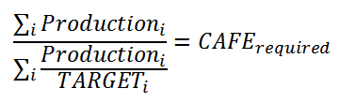
(Source: Centre for Climate and Energy solutions, 2014)
The downside of this approach is that the playfield is not level for large vehicle segments since compliance is easier for smaller ones. The standards were assessed by experts to have led to fuel savings of billions of barrels of oil over the years (Government Accountability Office, 2008).
With the support of the Obama administration, the US Environmental Protection Agency jointly with the National highway Traffic Safety administration has set fuel economy standards for 2017-2025 vehicles. Vehicles are classified on size basis for two broad categories: passenger cars and light trucks. Vehicle size (footprint) which is determined in a standardized way enters a formula that accounts as well for a manufacturer’s production or sales level. The standards are designed to accomplish a US fleet average fuel economy, by 2016, of at least 35.5 (GFEI, 2014). The target for 2025 is 54.5 mpg (New York Times, 2012). A shortcoming of that standards is restricting classifications of vehicles to size, which in light of the earlier discussion on the factors affecting energy efficiency of vehicles, is a factor among many.

Driving Cycles
Implementation of fuel economy standards requires the enforcing agency to test the fuel economy or consumption figures presented model manufacturers. The applicable driving cycle should mimic typical driving patterns, behavior stops, accelerations, speed ranges with duration for each of urban and highway driving. For comparison across vehicles, a combined or overall fuel consumption or economy cycle is used, combining urban and highway cycles with different weightage according to the cycle’s location origin. In the United States the used driving cycle is called Corporate Average Fuel Economy (CAFÉ). In Europe, the used driving cycle is called New European Driving Cycle (NEDC).
For the driving cycles to be fully representative, they need extensive detailed data about characteristics of driving in locations where they are applied. Also, the vehicles used for designing the cycle must match the running models. Other factors, such as roads elevation, air and wind need to be accounted for. Some claim that manufacturers design vehicles to match the driving cycle at the destination market’s cycle, if there is one.

Morocco in a North African context
Morocco is a North-African/ Arab country that has a GDP of $ 180 billion at purchasing power parity, with a real economic growth rate of 5.1% in 2013 up from 2.7% in 2012 while it was 5% in 2011 (CIA, 2014).
Morocco entertains levels of GDP per capita, at purchasing power parity, lower than Egypt’s, and considerably lower than Tunisia’s. It figured to 5,200, 5,300 and 5,500 for 2011, 2012 and 2013, respectively (CIA, 2014). Egypt, on the other hand, had a GDP per capita remaining constant at $6,600 over the period from 2011 to 2013 (CIA, 2014).
Morocco had a GINI index rounding up to 40 over the entire last decade (IMF, 2013). It was narrowly close to Tunisia’s and higher than Egypt’s, indicating a relatively more equitable distribution of income in Egypt.
Motorization rates in Morocco were 81 and 84 per one thousand inhabitants for the years 2011 and 2012, respectively- higher than the 50-odd rates of Egypt, but considerably lower than those of Tunisia standing in the range of one hundred and twenties. The higher motorization rates in Morocco despite Egypt’s better GINI coefficient, higher GDP per capita and cheaper highly subsidized motor fuel can be attributed to two factors. First, there is the higher rate of urbanization in Morocco where urban population makes up 57.77% of total population, whereas Egypt’s rate is 43.7 (Quandl, 2014). Cities of Casablanca, Rabat, Fes, Meknes and Agadir are highly urbanized and the levels of commuting are quite high (Focal Points, 2014). In Egypt, relatively high levels of urbanization and commuting are confined to Cairo. Tunisia, on the other hand, has a high level of urban population of 66.75% (Quandl, 2014).
Figures 1 shows the total number of cars on the road for Tunisia, Egypt and Morocco. Figure 2 shows the sales of new LDVs in Tunisia and Egypt for the years 2005, 2008, 2010 and 2012. Figure 3 shows the sales of new LDVs in Morocco for the years 2009, 2012 and 2013.

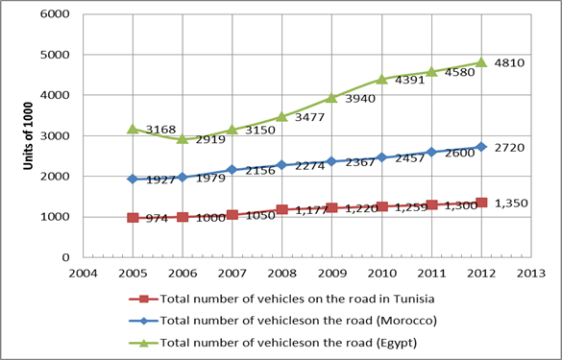
Figure 1: Total Vehicles on the road. (OICA 2014)
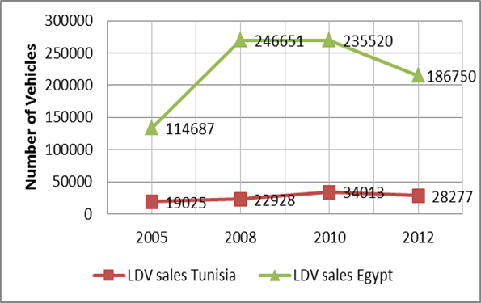
Figure 2: Sales of new LDVs in Tunisia and Egypt. (Matthias Gasnier 2014)
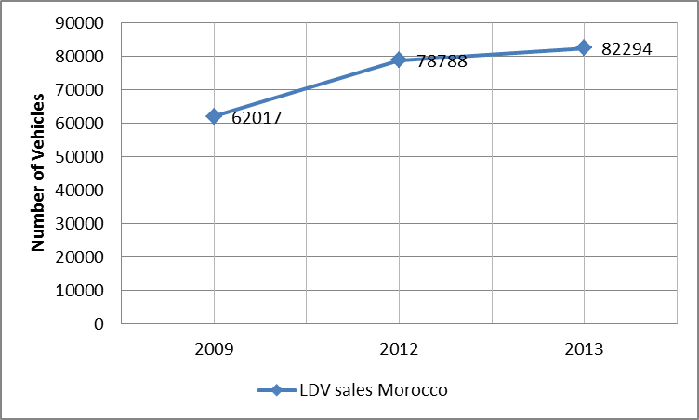
Figure 3: Sales of new LDVs in Morocco. (Matthias Gasnier 2014)

The total number of vehicles on the road, shown in Figure1, reflects the difference in population sizes and growth rates. Tunisia’s population has remained around 10 million since 2006; Morocco’s population has increased by about 2 million to around 32 million from 2006; Tunisia’s population has remained around 10 million since 2006 while Egypt increased by 12 million to around 82 million over the same period (Quandl, 2014). Moroccan population growth rate in 2014 has been 1.02%
GDP growth in Morocco has averaged 4.43 from 1999 to 2014 with only two incidences of sharp fluctuations (tradingeconomics.com, 2014). The steady GDP growth and the low population growth rates compared to Arab countries are concomitant with a constant steady increase of total vehicles on the road of 2.36 million, 2.45 million, 2.6million and 2.72 million for 2009, 2010, 2011 and 2012, respectively (OICA, 2012).
Sales of new LDVs, on the other hand, were 64,517, 79,627, 82,294 vehicles for 2009, 2012 and 2013, respectively. The increase in sales can be attributed to elements of the Moroccan policy environment, which are discussed in the next section.

LDVs Policy Environment in Morocco
Since 1999 Morocco has been embarked on an accelerated path towards trade liberalization and a market oriented economy. Now prices are determined according to market forces without substantial government interference. All goods and services may be imported. This comes in line with a Moroccan policy of developing local industries, especially in technologically intensive industries where automotive industry upholds a key position in government strategy.
Free trade agreements signed with USA, Turkey, Arab Countries and European Union (EU) leverages Morocco with free access to diverse markets. Meanwhile, that orientation serves Moroccan aspirations of turning into a regional hub for automotive industries. Government policies are put in place to capitalize on Morocco’s trade relations. Industrial free zones are dedicated to automotive manufacturers; training programs are set up to prepare specialized labor, that is, in addition to tax breaks and capital assistance to tooling and buildings.
VAT is levied on both local made cars and imported ones in two different schemes. For imported ones it includes the due domestic consumption tax, import duties, if any, and the customs value. The VAT rate varies between 7% and 20% (PKF, 2012), taking into account trade agreements and investment relations with producer. In 2012 custom duties on cars imported from EU were eliminated. Asian cars are subject to 17.5% import duties, while Free Trade Agreement with the USA had led to lowered import tariffs on American cars (Focal Points, 2014).
The EU also happens to be the biggest market of Moroccan made cars. For the Moroccan consumer, a diversified market exists with free competition between authorized dealers of various brands, where European producers who also happen to be the major investors in Moroccan domestic LDVs production take up the lion’s share. Second and third tier automotive industries exist as well in Morocco with a considerable role for Asian companies which have set up their production lines in Morocco. Asian producers have been lobbying for import duties deductions to boost their competiveness with European ones though it seems that the key determinant in that regard is investment in domestic production. Nonetheless, the lobbying process and the provision of venues for the expression of interests of competing producers and importers are taken as indicators of a healthy and dynamic market.
All in all, tariff barriers on imported vehicles are significantly low in comparison with Tunisia and Egypt with an end result of citizens having access to many brands at relatively affordable prices.
Fuels for LDVs in Morocco are subsidized, though the subsidy system is much less intense than other Arab countries. With rising international oil prices, Morocco has been subsiding retail fuel since 2000 while they had been indexed to international prices before that year. Starting from 2012/2013 fuel subsidies have been capped and linked to oil prices fluctuations (CIA, 2014).
The slashing of tariffs on European vehicles was followed by an increase in annual taxes proportional to the vehicle’s horsepower. Apart from initial registration fees of 50 dirhams for each boiler horsepower, annual taxes on vehicles were increased on a horsepower sliding scale for different horsepower ranges of 8 or less, 11-14 and 15 or more. Luxury vehicles, defined as having a market cost of 400,000 dirhams were liable a trifold duties, including a rate that is function of the cost in addition to the standard initial registration fees and horsepower taxes.
The slashing of tariffs on European vehicles had a noticeable impact on LDVs sales in 2012 which witnessed a surge to 79,627 vehicles compared to the 64,517 vehicles of 2009. The fuel subsidy capping and the increased annual taxes put a lid on what might otherwise have been an inexorable rise in LDVs sales in 2013 where new LDVs sales rose only slightly to 82,294 vehicles.
All the same, luxury LDVs sales continued to rise in 2013 and the first quarter of 2014 showing that the employed tools of vehicles taxation and fuel pricing do not generate a palpable impact on the said segment.

Data for CO₂ Emissions and Fuel consumption in Morocco
Figure 4 shows the evolution of LDVs CO2 emissions in Morocco for the years 2009, 2012 and 2013. The weighted average was calculated according to the GFEI methodology. Also, unweight average CO2 emissions for LDVs was calculated for the same years. The unweight average discounts the impact of sales figures for different models
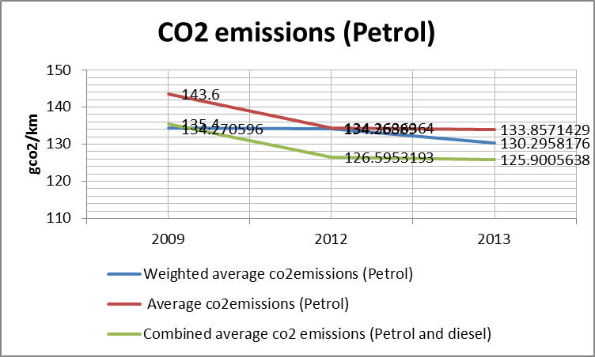
Figure 4: Different Averages for CO2 emission in Morocco

Petrol LDVs weighted average for co₂ emissions was 134.2706 gco₂/ km in 2009. In 2012 it remained almost the same at 134.2 gco2/km followed by a decrease to 130.2gco2/km in the next year. When it came to average CO₂ emissions they were 143.6 gco2/ km in 2009, considerably higher than weighted average for the same year. In 2012, they dropped to 134.3 gco₂/ km equal to the weighted average for the same year then dropping further in 2013 to133.8 gco₂/km, yet they were more or less equal to the corresponding weighted average.
Combined weighted average for petrol & diesel LDVs had been significantly lower than petrol’s for the years 2012 and 2013, respectively. However, in 2009 they had been all but equal to the weighted average of petrol at 135.4 gco₂/ km. They had been consistently following the pattern of diesel LDVs as shown in Figure 5.
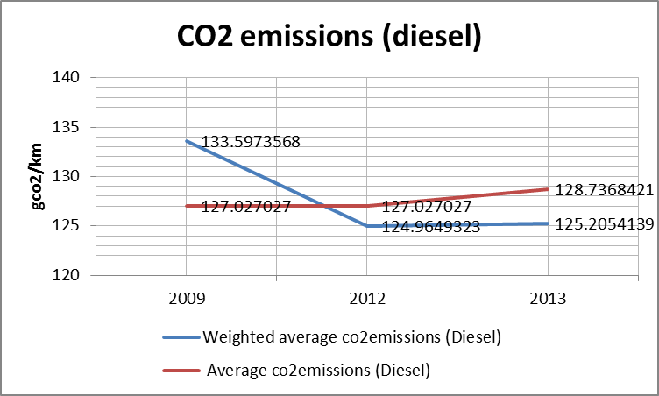
Figure 5: Different Averages for diesel CO2 emissions in Morocco

In 2009, weighted average co₂ emissions for new diesel LDVs were at 133.5974 gco₂/ km slightly lower than petrol’s. In 2012, the figure was 124.9649 gco2/ km rising minimally to 125.2054 gco2/ km in 2013. The figures were significantly lower than petrol LDVs for 2012 and 2013.
Average co₂ emissions for new diesel LDVs were significantly lower than weighted ones at 127.027 gco₂/ km in 2009. In 2012 and 2013 they were higher than weighted averages at 127.027 and 128.7 gco₂/ km, respectively.
Fuel Consumption Trends
Figure 6 shows fuel consumption (L/100km) trends for new petrol LDVs in Morocco for the years 2009, 2012, and 2013.
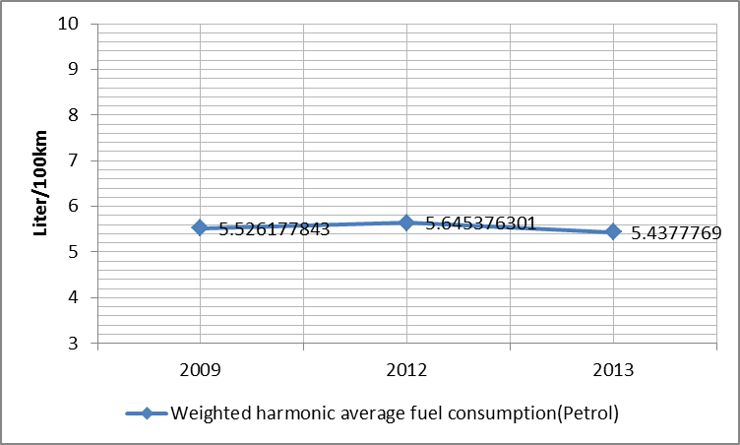
Figure 6: Petrol Fuel Consumption for LDVs in Morocco

The weighted harmonic averages of fuel consumption for new petrol LDVs were close for the years 2009 and 2012 at 5.52 liter/100 km and 5.6 liter/100 km, respectively. In 2013, they dropped to 5.43 liter/100 km. Figure 7 shows the aforementioned trend for diesel vehicles.

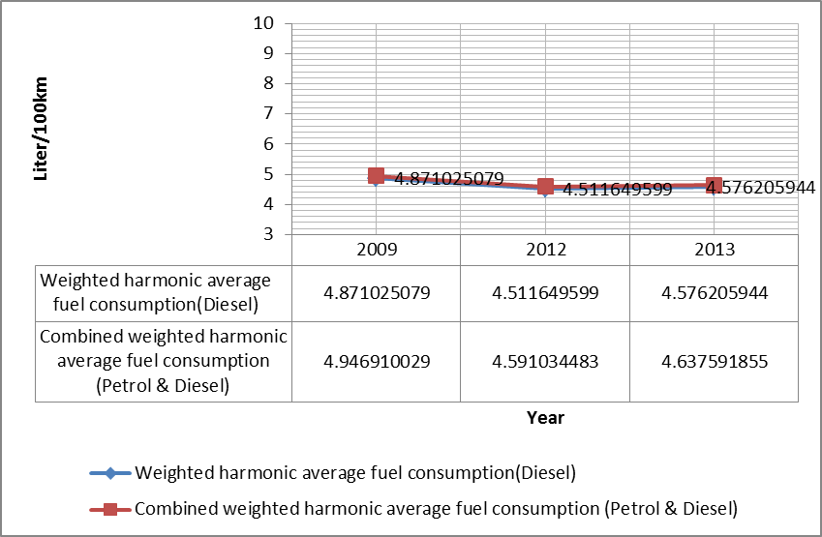
Figure 7: Diesel Fuel Consumption for LDVs in Morocco

The figures for weighted harmonic average fuel consumption for new diesel LDVs were both constant, at four plus several decimal point Liters/100km, and lower than petrol figures for all the study years.

Discussion of Data
Non-OECD fuel economy averages for LDVs in L/100km for 2005, 2008 and 2011 were 7.5, 7.6, 7.5, while OECD averages were 8.1, 7.6 and 7 (Fuel Economy State of the World, 2014). Morocco fared very well in comparison with the two said groups; with fuel consumption levels well below their averages at few decimal points above 5 l/100 km for petrol LDVs. Fuel consumption levels were even better for diesel LDVs which stood at levels of few decimal points above four Liter/100km. These sustainable levels for fuel economy/ consumption were the outcome of high fuel prices using a Middle-Eastern benchmark, which in turn is driving public awareness of fuel economy/consumption considerations; especially that World Bank ranks Morocco as a lower middle income country. The high levels of commuting in several Moroccan cities and the inter-town traffic bring to the for a fuel economy/consumption criterion on buying LDVs.
For petrol LDVs, CO₂ emissions rates followed the same pattern of change of fuel consumption for the study years since there is a strong causation between fuel consumption and CO₂ emissions.
The above is applicable to diesel LDVs CO₂ emissions rates as well. In 2009, the CO2 weighted average emissions for diesel LDVs were significantly higher than those in 2012 and 2013. This is due to considerable sales in 2009 of certain models that were not sold in 2012 and2013. Those were: Toyota Prado, Toyota Corolla, Volkswagen Passat, Kia Sportage and Kia Carens. Those models have high levels of CO₂ emissions which affected tangibly the weighted average of LDVs sales. This impact was not much fleshed out for Fuel economy/consumption since the span of difference between the calculated harmonic average for the year and the fuel economy/consumption averages of the said models is not large on an absolute scale.
Fuel economy/ consumption of diesel LDVS had been lower than petrol ones for the entire reported years despite the use of larger diesel LDVs with larger engine sizes. Generally, diesel engines show better fuel consumption than petrol ones unless the characteristic is offset by vehicle features such as a much larger engine size or body weight. That for all the study years 80-odd percent of the new LDVs sold were diesel-fuelled, which fielded better fuel economy/consumption than petrol ones despite having larger engine sizes, has had a desirable impact on the overall fuel economy/consumption. Diesel LDVs weighted average co₂ emissions were consistently lower than petrol ones. That was not the case for Tunisia where diesel LDVs emissions had always been higher than petrol. This is because the high level of fuel-efficiency consciousness in Morocco promotes the use of diesel vehicles in economic and ordinary market segments. For Tunisia, apart of commercial vehicles, diesel LDVs sales were mostly for luxurious vehicles with high co₂ emissions levels causing the co₂ emissions of diesel LDVs to be higher than those of petrol ones .
Weighted average co₂ emissions for new diesel LDVs was higher than unweight average for 2009. In 2012, the weighted average overtook the unweight average, whereas in 2013 it went below the unweight average. In 2009 there were less diversity of marketed models and variants and the largest sales volumes were for energy efficient vehicles- with considerable sales volumes for brands with high emission levels. Apparently, the slashing of tariffs on European vehicles increased the diversity in the market exhorting the purchase of luxurious vehicles.
The abovementioned pattern took a different twist for petrol LDVs, for weighted average LDVs co₂ emissions were lower than average emissions in 2009. As of 2012, weighted average had dropped below the average ones. An explanation that could be summoned to explain the opposing trends in 2009 might be related to gender preferences. The bulk of the Moroccan market comprises diesel LDVs which is preferred by men who cover higher commute distances and hence fuel economy considerations come to the fore. Alas, as of 2012 the trend mounted a course of reversal for both petrol and diesel LDVs since with the increasing diversity there has been a wider variety of the comparatively less efficient luxury cars, which sales witnessed an increase as of 2012, trumping fuel efficiency considerations. A room therefore exists for improving on the fuel consumption/economy for both petrol and diesel LDVs by bringing the weighted average curve and unweight one closer to each other.
Year 2009
For petrol LDVs, Hyundai I10, Kia Picanto, Dacia Logan, Dacia Sandero, Fiat Punto, Fiat Albea and Suzuki Alto made up about 85% of total Petrol LDV sales.
For diesel LDVs, Dacia Logan, Fiat Doblo, Peugeot Partner, Citroen Berlingo, Dacia Sandero, Ford Fiesta, Toyota Corola, Renault Megane, Peugeot 206, Renault Symbol, Peugeot 308, Peugeot 207, Volkswagen Passat, Hyundai Accent, Hyundai Santa-Fe, Volkswagen Touareg, Volkswagen Polo, Toyota Prado, Renault Clio and Kia Carens made up 87% of diesel LDVs sales.
The fuel consumption/economy of the best- selling 85% Petrol LDVs had a higher incidence of vehicles with a fuel consumption/economy exceeding 5 Liters/100 km. Thus it is fathomable that fuel consumption/economy for new petrol LDVs was higher than that for diesel.
Year 2012
Hyundai I10, Fiat Punto, Ford Focus, Dacia Logan, Dacia Sandero, Renault Clio, Peugeot 206, Ford Fiesta, Volkswagen Polo, Dacia Duster, Peugeot 208 and Renault Megane made up 91% of the sales of new petrol LDVs. Fuel consumption/economy levels remained almost the same, with a minuscule rise from 5.52 liter/100km to 5.6 liter/100 km. The diminutive increase is attributed to a larger variety of models and variants though the total sales of new LDVs decreased.
Dacia Logan, Dacia Sandero, Dacia duster, Ford Fiesta, Fiat Doblo, Peugeot 206, Citroen Berlingo, Peugeot Partner, Renault Clio, Nissan Qashqai, Volkswagen Polo, Renault Megane, Dacia Dokker, Hyundai ix35,Peugeot 308, Ford Kuga, Peugeot Biper, Citroen C4, Hyundai Accent, Citroen C3, Opel Astra and Hyundai i30 made up 87% of new diesel LDVs sales. It is that most of them had fuel economy/consumption levels in the order of 3 and 4 liter/100km which explains the better fuel economy/consumption harmonic average of diesel LDVs than petrol ones. The fuel economy/consumption levels for new diesel LDVs witnessed a small improvement from 4.87 to 4.5 due the improvements in fuel consumption/ economy of diesel models sold on 2012- notwithstanding the much larger sales volumes in 2012.
Year 2013
Hyundai I10, Fiat Punto, Dacia Sandero, Renault Clio, Peugeot 208, Ford Focus, Dacia Logan, Ford Fiesta, Dacia Duster, Peugeot 301, and Volkswagen Polo made up 89% of new petrol LDVs sales for 2009. The improvement is attributed to the fact despite the models and variants sold in 2013 were much similar to those of 2012, the less efficient Dacia models, Renault Megane, Ford Focus and Peugeot 206 sold less in 2013.
Dacia Logan, Dacia Duster, Dacia Dokker, Dacia Sandero, Ford Fiesta, Fiat Doblo, Renault Clio, Ford Focus, Peugeot 301, Citroen Berlingo, Nissan Qashqai, Hyundai ix35, Peugeot Partner, Volkswagen Polo, Peugeot 206, Peugeot Biper, Hyundai i30, Ford Kuga, Renault Megane, Opel Astra, Hyundai Accent, Citroen C-Elysee, Hyundai Santa-Fe, Citroen C4 and Ford Transit were up to 91% of new diesel LDVs sales for 2013. Fuel consumption/efficiency harmonic average figure increased by 0.06 liter/100 km because there had been no sizeable improvement in fuel efficiency of models sold in Morocco from 2012 to 2013, while the sales volumes of new diesel LDVs increased by more than a couple of thousand vehicles with a bit more marketed models and variants.

Way Forward and Recommendations
For the years trended in the report, Morocco managed to maintain outstanding fuel consumption rates on a weighted average scale. The weighted harmonic averages of diesel LDVs, which comprise the bulk of the market sales, were considerably lower than both OECD and non-OECD averages and even performing better than the Tunisian case. Petrol LDVs also showed a similar trend though they were close to Tunisian averages. However, it need to be empathized that fuel consumption/economy of many LDVs models has been improving since 2005, yet still Moroccan LDVs fared better in fuel consumption/economy for the years 2012 and 2010.
Both European and domestic production of European brands dominate the Moroccan market by far. Thus, the European increasingly stringent fuel consumption/efficiency standards have impacted Morocco as well. That a large share of Moroccan domestic production is exported to Europe drives the Moroccan made cars to keep up with European ones in terms of fuel consumption/economy. Furthermore, the lower GDP per capita in Morocco compared to the manufacturing origin of the brand coupled with relatively high fuel prices, though still lower than international prices, pushes the Moroccan market towards the lower end of the engine-size spectrum. Also, the variants sold in Morocco are usually of smaller horsepower. Lumped together, the number of factors being discussed provides a viable explanation of the exemplary fuel consumption/economy performance of Moroccan market. Yet, this is by no means the best of all possible worlds since the variants sold in Morocco are more often than not less fuel efficient than ones of the same horsepower and engine size.
Still, nevertheless, LDVs sold in Morocco boast more technological sophistication than Tunisian ones with the market showing preferences for lower engine sizes. Although the LDVs market in Morocco is free to a large extent, with a regulatory slant favoring European producers, government set the playing field for the introduction of modern energy efficient diesel LDVs by the enforcement of fuel quality standards of Euro 4/5 diesel rendering the marketing of modern technology diesel vehicles possible. The privatized refining industry responded positively to government regulation. Meanwhile, the pump price of diesel in Morocco is cheaper than petrol pushing for an increased demand for the fuel-efficient diesel LDVs, in the efficiency sensitive Moroccan market.
Despite the satisfactory fuel consumption/ efficiency averages for morocco, co₂ emissions from transportation have been on constant rise in the period from 2005 till 2011, as shown in Figure 8.
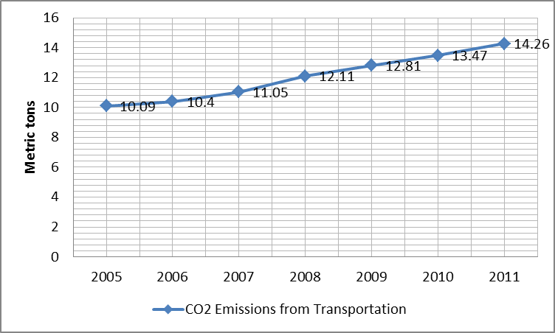
Figure 8: The evolution of co2 emissions from Transportation in Morocco

Transportation CO₂ emissions include heavy duty vehicles, yet the constantly rising trend point to the need for curbing the increasing petrol and diesel consumption indicted by increasing emissions. Improving the fuel consumption/economy of LDVs fleet in Morocco should thus be highlighted in Moroccan energy policy and transportation agenda
The discrepancy between the average co₂ emissions curve and weighted average one shows the presence of a room for improvements. The Moroccan export oriented automotive industry which satisfies part of the domestic demand as well puts limits on the possibility of introducing fuel consumption/economy standards so as not affect the competiveness of the Moroccan nascent automotive industry. On the flip side, however, Morocco is not a “Maquiladora” hub since government policies aiming at embedding technology and building second and third tiers automotive industries gives the Moroccan government some leverage in regulating the automotive market. Morocco’s access to diversified markets while being located at the junction of Europe and Africa takes this purported leverage a step further.
The targeted European market is drifting towards stricter fuel consumption/economy standards; a trend which Morocco can invest in to gain a strategic advantage in what is perceived as the future trump card of its economy. Morocco entertains a huge and diversified public transportation network including Trams and 3 million public service buses of which as much as a half are found in Casablanca and Rabat where commute levels peak, whereas the eastern and southern parts of the country have much lower commute levels. Thus, an enabling condition for policies that ultimately aim at curtailing motor fuel consumption is in place as it is.
The Moroccan orientation towards an increasingly liberalized economy, free trade agreements and vision for the future all rule out the possibility of the implementation import restrictions instruments; market-based regulation is what suits the Moroccan policy environment. A combination of registration fees and vehicle taxation is already implemented.
However the taxation and registration fees, being solely based on vehicles’ horsepower, though a good step as such, are not suffice to bring about Fuel consumption/efficiency averages close to the ceiling of its constraints. This is because lower horsepower variant sold in Morocco and other variants is not much significant as far as fuel consumption/economy is concerned. Instead, a combination of engine size and weight should be the basis of annual vehicle taxation and registration fees. Another intervention, which must one way or another be synchronized with the advancements in domestic industry, is the design of policies targeting technological attributes of domestic vehicles production towards the end of employing optimum fuel efficient vehicle technological attributes combo.
The experiences and knowledge of GFEI render it a candidate for playing an important role in a Moroccan fuel consumption/economy policy. With the current and prospective levels of motor fuel consumption taken as an overarching framework and the right market signals received from sold models and variants in Morocco, GFEI can come out with a proposal for reducing fuel consumption through in absolute terms. This is carried out through a combination of stepped instruments, including green taxes for vehicles on fuel consumption levels, more comprehensive annual vehicle taxation & registration fees, as well as a technological attributes regulation of domestic industry.

References List
- Center for Climate and Energy Solutions (C2ES). (2014). Federal Vehicles Standards. Available at: http://www.c2es.org/federal/executive/vehicle-standards. Accessed: September 10th, 2014.
- Central Intelligence Agency (CIA): Tunisia (2014). Available at: https://www.cia.gov/library/publications/the-world-factbook/geos/ts.html. Accessed: July 29th, 2014.
- Central Intelligence Agency (CIA): Morocco (2014). Available at: https://www.cia.gov/library/publications/the-world-factbook/geos/mo.html. Accessed: August 3rd, 2014
- Central Intelligence Agency (CIA): Egypt (2014). Available at: https://www.cia.gov/library/publications/the-world-factbook/geos/mo.html. August 5th, 2014.
- Chiaberge, Marcello (2011). New Trends and Developments in Automotive System Engineering. Intech: Rejeka.

- Global Fuel Economy Initiative, 2013. Global Fuel Economy Initiative: 50by50. http://www.globalfueleconomy.org/about/Pages/AboutHome.aspx. Accessed: September 8th, 2014.
- Global Fuel Economy Initiative: GFEI (2014). Available at: http://www.unep.org/transport/gfei/autotool/nextsteps/developing_a_baseline.asp. Accessed: August 19th, 2014
- Global Fuel Economy Initiative: GFEI (2014). The European Union Automotive Fuel Economy policy. Available at: http://www.unep.org/transport/gfei/autotool/case_studies/europe/cs_eu_0.asp. Accessed September 11th,2014
- Global Fuel Economy Initiative: GFEI (2014). The US Automotive Fuel Economy policy. Available at: http://www.unep.org/transport/gfei/autotool/case_studies/northamerica/cs_us_0.asp. Accessed: September 14th, 2014.
- International Monetary Fund: IMF (2013). Morocco Selected Issues. Washington, DC: IMF Publications Services.
- Institute of Mechanical Engineering (2011). Internal Combustion Engines: Improving Performance, Fuel Economy and Emissions. Woodhead Publishing Limited: London

- Parry, Ian. Anderson, Soren. Sallee, James M. Fischer, Carolyn. (2010). Automobile Fuel Economy Standards: Impacts, Efficiency, and Alternatives. Resources for the Future: Washington, DC.
- PKF International Tax Committee (2012). Morocco Tax Guide 2012. United Kingdom: PKF International Limited
- Quandl (2014). Egypt GINI index. Available at: https://www.quandl.com/WORLDBANK/EGY_SI_POV_GINI-Egypt-Arab-Rep-GINI-index. Accessed: September 18th, 2014.
- Quandl (2014). Egypt population data. Available at: https://www.quandl.com/UN/DEV_POPULATIONTOTAL_EGY-Population-Total-Egypt. Accessed: September 20th, 2014.
- Quandl (2014).Morocco GINI index. Available at: https://www.quandl.com/WORLDBANK/MAR_SI_POV_GINI-Morocco-GINI-index. Accessed: September 18th,2014
- Quandl (2014) Morocco Population data. Available at: https://www.quandl.com/UN/DEV_POPULATIONTOTAL_MAR-Population-Total-Morocco. Accessed: September 20th, 2014.
- Quandl (2014). Tunisia GINI index. Available at: https://www.quandl.com/WORLDBANK/TUN_SI_POV_GINI-Tunisia-GINI-index. Accessed: September 18th, `2014.
- Quandl (2014). Tunisia Population data. Available at: https://www.quandl.com/UN/DEV_POPULATIONTOTAL_TUN-Population-Total-Tunisia. Accessed: September 20th, 2014.
- Stone, Richard (1992). Introduction to Internal Combustion Engines. 2nd edition. The Macmillan Press Limited: London.

- The globaleconomy.com (2014). Morocco co₂ emissions from transportation. Available at: http://www.theglobaleconomy.com/Morocco/CO2_emissions_from_transportation/. Accessed: October 14th, 2014.

- The International Organization of Motor Vehicle Manufacturers (OICA). Total in Use 2012. Available at: http://www.oica.net/category/about-us/. Accessed: September 4th, 2014.

- Tradingeconomics.com (2014). Morocco GDP Growth Rate. Available at: http://www.tradingeconomics.com/morocco/gdp-growth . Accessed: October 20th, 2014.

- United States of America. Government Accountability office (2008). Vehicle Fuel Economy. New York: Novinka books.

FIA Foundation, International Energy Agency (IEA), International Transport Forum (ITF), United Nations Environment Programme (UNEP), and the International Council on Clean Transportation (ICCT).

