|  |  |
| --- | --- |
| **cid:_1_16E9392816E936BC004609BE43257D64** | **cedare** |

**Fuel Consumption/Economy Trends in LAS countries:**

**The Tunisian Case Study**

**Author**

Amr El-Abyad

**Contributors**

Hossam Allam

Matthias Gasnier

**Center for Environment and Development for the Arab Region and Europe (CEDARE)**

**Oct 2014**

cid:_1_16E9322016E92FB4004609BE43257D64

Table of Contents

[1 Introduction. 3](#_Toc400533322)

[1.1 Objectives 3](#_Toc400533323)

[1.2 Approach 3](#_Toc400533324)

[1.3 Limitations 5](#_Toc400533325)

[2 Background information 6](#_Toc400533326)

[2.1 Fuel Economy 6](#_Toc400533327)

[2.2 Factors Affecting Fuel/Consumption Economy 6](#_Toc400533328)

[2.3 Fuel Economy Standards 8](#_Toc400533329)

[2.4 Driving Cycles 9](#_Toc400533330)

[3 Tunisia in North-African Context 9](#_Toc400533331)

[4 LDVs Policy Environment in Tunisia 12](#_Toc400533332)

[5 Data for CO2 Emissions and Fuel consumption in Tunisia 13](#_Toc400533333)

[6 Discussion of Data 15](#_Toc400533334)

[7 Way Forward 17](#_Toc400533335)

**Table of Figures**

[Figure 1: Total number of vehicles on the road. (OICA 2014) 10](#_Toc400532645)

[Figure 2: Sales of new LDVs in Tunisia and Egypt (Matthias Gasnier, 2014) 10](#_Toc400532646)

[Figure 3: Sales of new LDVs in Morocco (Matthias Gasnier, 2014) 11](#_Toc400532647)

[Figure 4: Different averages for co2 emissions in Tunisia 13](#_Toc400532648)

[Figure 5: Different averages for diesel CO2 emissions in Tunisia 13](#_Toc400532649)

[Figure 6: Petrol fuel consumption for LDVs in Tunisa 14](#_Toc400532650)

[Figure 7: Diesel fuel consumption for LDVs in Tunisia 14](#_Toc400532651)

[Figure 8: Evolution of motor petrol consumption in Tunisia (The globaleconomy.com, 2014) 18](#_Toc400532652)

# Introduction.

The transport sector is responsible for 27 % of the world energy consumption (IEA, 2012). This proportion has increased from 23% in 1973 (IEA, 2011) and contributes to 22 % of total CO2 emissions (IEA, 2012).

A growing international concern over climate change induced by the burning of fossil fuels has been accelerating. Also the security and sustainability of oil supplies are subject of growing global concerns. In response to those challenges many countries all over the world are working on curbing oil consumption and finding alternative resources. That’s why many countries worldwide have introduced fuel consumption/ economy or CO2 emissions standards towards the end of improving vehicles energy efficiency. A number of initiatives around the world have been introduced to help countries with regard to fuel efficiency/ economy standards. The Global Fuel Economy Initiative (GFEI) comes as an effort of five organizations[[1]](#footnote-1) to promote improvements in vehicle fuel economy. This initiative aims to achieve 50 % improvements by 2050 in all vehicles globally compared to that in the year 2005. The initiative’s main activities include: data development and analysis, policy support, and awareness raising (GFEI, 2013).

## Objectives

In line with the United Nations Environmental Program (UNEP) work on promoting sustainability and the GFEI’s efforts in prompting the introduction of more energy efficient vehicles, this report comes as part of sequel aiming to analyze the status and trends of fuel consumption/economy standards in at least four Arab countries as the region still lacks fuel consumption/economy standards. This report presents an analysis of the Tunisian case study and eventually comes out with a discussion on how to facilitate the introduction of standards in Tunisia and the associated recommendations.

## Approach

The report is about the trend patterns in fuel consumption/economy and CO2 emissions. It views the status of emissions and fuel consumption through the lens of changing weighted averages for new Light Duty Vehicles (LDVs) for the years 2005, 2008, 2010 and 2012. Thus the report provides a sense of changing state of emissions and Fuel consumption in Tunisia

Accordingly, figures for sales of new Light Duty vehicles have been obtained along with the official figures for CO2 emissions and fuel consumption for almost all the models. Figures for total LDVs on the road for the study years have also been obtained to put the trends in perspective and to feed into the report’s discussion on improving fuel consumption/economy and the associated recommendations.

Figures for new LDVs sales in 2008, 2010 and 2012 have been obtained from manufacturers and were collected by an automotive markets consultant, Matthias Gasnier. For reliability, the figures were cross-checked with sample figures for new LDVS sales from IHS consulting as well as total figures of different model sales in Tunisia obtained from the International Organization of Motor Vehicle Manufacturers (OICA). Further, figures obtained from the Egyptian Manufacturers Information Council (AMIC) were used as well in cross-checking. Data are classified by Vehicle’s make; model; fuel type and engine size.

The 2005 figures were estimated based on certain characteristics of the Tunisian market, which is unique in the world. The Tunisian market is influenced for the most part by import quotas dictated each year by the government. There is no local car manufacturing industry in Tunisia, so 100% of cars sold in the country are imported, meaning the import quotas dictate for the most part the Tunisian new car market. This makes the Tunisian car market very predictable as its evolution is somehow disconnected to market forces and consumer taste.  Accordingly, 2005 figures were obtained taking into consideration a few long-term trends in the Tunisian new car market. These trends are as follows:

* All estimated figures are taking into account 2005 total market sales data made available by the Tunisian government, which show a 29% overall increase between 2005 and 2008
* Increased fragmentation of the quotas allocated between 2005 and 2008 due to the increase in the number of brands and models allowed to be imported into Tunisia means the best-selling models had on average a larger market share in 2005 than they do in 2008
* Some high selling brands like Dacia, Kia and Hyundai were only allowed import quotas from 2010 onwards, therefore their 2005 sales are nil.
* Long-term trend towards increased fragmentation of premium brands such as BMW means the Series 3 held a larger market share in 2005 than in the years following
* Specific sales evolution takes into account the launch date of some models and their 2005 sales are estimated based on the career stage these models were at in 2001. For example the Peugeot 307 launched in 2001 and the Peugeot 206 in 1998 meaning their sales peaked between 2003 and 2006 regardless of the evolution of the overall market
* Long-term decrease of Volkswagen's share of overall quotas in the country means their models had a larger share on average in 2005 than in the years following.
* Long-term observed trend towards a weaker share of quotas for Commercial Vehicles means models such as the Peugeot Partner or Citroen Berlingo had a larger share of the Tunisian market in 2005
* The estimated margin of error for each 2005 sales figure is +/20%

Manufacturers’ specifications manual and compilations of the French Environment and Energy Management Agency (Ademe) have been used to arrive at the manufacturers’ labeled figures for fuel consumption/economy and CO2 emissions. Then GFEI methodology (GFEI, 2014) has been used in calculating the weighted harmonic average annual fuel consumption/economy, and the weighted average annual CO2 emissions:

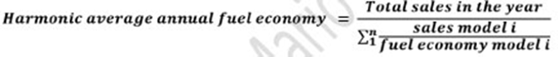



The definition of the GFEI for LDVs has been used in deciding on the vehicles to be included in the report study (GFEI, 2014). The definition is as follows:

Table 1: The GFEI definition of LDVs

|  |  |
| --- | --- |
| Vehicle Segment | Examples |
| A: Mini / Micro / Small town car *Smallest cars, with a length between 2.50m to 3.60m.* | Citroën C1  Fiat Panda Smart Fortwo |
| B: Small compact  *Slightly more powerful than the Minis; still primarily for urban use; length between 3.60m and 4.05m* | Mitsubishi Colt  Opel Corsa  Suzuki Swift |
| C: Compact  *Length between 4.05m – 4.50m* | Mazda 3  Subaru Impreza Volvo S40 |
| D: Family cars  *Designed for longer distance; fits 5- 6 people; length is 4.50m to 4.80m* | BMW 3 series  Chrysler Sebring  Lexus IS |
| Light vans  *Size is similar to D, but interior volume is maximized to accommodate larger families* | Chevrolet Uplander  Ford Galaxy Volkswagen Sharan |
| Big / Full size cars *Have generous leg room; can comfortably transport 5 - 6 people; generally have V8 engines and are 5m or longer in length* | Cadillac DTS  Jaguar XJ  Mercedes-Benz E Class |
| SUV / All terrain  *The original cars were utility cross-country vehicles with integral transmissions like the Jeep* | Dodge Durango  Jeep Grand Cherokee  Nissan Patrol Toyota Land Cruiser |

## Limitations

Tunisia has no indigenous driving cycle, an issue which is thoroughly discussed in the way forward section. Since the Tunisia market is in broad terms more streamlined with the European one, the study team obtained data for fuel economy/consumption based on the New European Driving Cycle (NEDC).

Because for some models the emissions figures were not available, the report eliminated those models from its analysis. Those models have made up a maximum of 1 % of all models all over the study years. Another limitation is the new LDVs sold through unauthorized dealers and parallel markets which are not to exceed 10% of total new LDVs sales. Therefore the studied new LDVS in the report comprise 89% of total new LDVS in Tunisia for the study years, at worst.

# Background information

## Fuel Economy

Fuel economy is a measure of the maximum distance that can be covered by a vehicle per unit of fuel. The most common metric of fuel economy is miles per gallon (mpg), which is especially, used in the United States. Kilometers per liter can also be used.

***Fuel Consumption***

Fuel consumption is the mathematical reciprocal of fuel economy. It is a measure of the amount of fuel consumed covering a given distance. It is measured in liters per 100 km in Europe and most of the world. In the United States it is measured in gallons per 100 miles. Being the reciprocal of fuel economy necessarily entails that for fuel consumption the relation. This in turn renders more instrumental in communicating the fuel savings, from improving fuel economy, in absolute terms to lay consumers. This is because the amount of fuel saved in improving fuel economy in the lower ranges of mpg is significantly higher than those at the higher ranges. Hence the benefits accrued from improving the fuel consumption of vehicles become more comprehensible to the average consumer.

## Factors Affecting Fuel/Consumption Economy

The report tackles two broad types of vehicles classified according to the fuel they utilize. Petrol powered engines (petrol fuelled vehicles), referred to as spark ignition engines, rely for the most part on a thermodynamic cycle, called Otto cycle. For petrol engines, a spark plug is used to ignite an air/fuel mixture exerting work on piston, which moves vertically inside a hollow cylinder, then mechanically transmitted to a crankshaft and through a clockwork of gears to the wheels. Diesel powered engines (Diesel fuelled vehicles) rely on heat generated from the compression of diesel/air mix for ignition and operating the pistons. For both types of internal combustion engines, 75% of the energy is wasted to coolants and exhaust with the rest doing the propelling work.

***Vehicle Energy efficiency***

* **Engine:** The engine output power varies with its torque and speed. For each engine there is three-dimensional curves plotting the output power against both Torque and speed. From this curve an optimum zone is located where the engine’s energy efficiency is maximized. In reality the vehicles runs through various driving ranges and modes at points outside the energy efficient zone. Using turbo charging, smaller engines all drive engine towards operation at the maximum efficiency zone (Institute of Mechanical engineers, 2011).
  + **Combustion interval:** short combustion interval allows for more of the generated heat to be used in driving the pistons
  + **Higher compression ratio and optimized exhaust valve opening**: Compression ratio is the volume between the volumes of the combustion chamber when the cylinder is at the bottom stroke to that when the cylinder is at top stroke. Better control of exhaust valve opening improves the energy efficiency of engine (Institute of Mechanical Engineers, 2011).
* **Pump losses:** The pump lossesresult from pressure gradients along the piston, so it is the extra work required to suck air in and out of inlets (Chiaberge, 2011).
* **Friction losses:** Friction lossesresult frompiston andcrank shaft mechanical connections. Improving precision of cylinder dimensions minimizes piston friction losses. Crank shaft bearing design and features have a straightforward impact on the associated friction losses (Institute of Mechanical engineers, 2011).
* **Oil and coolant pumps:** following the wide-spread recommendations for reducing energy consumption of pumps are applicable for automotive engines.
* **Power steering:** using electric drives for power steering reduces fuel consumption
* **Aerodynamics:** air resistance to a vehicle’s traction, termed drag force is dependent on a factor called the drag coefficient. Reducing drag coefficient reduces fuel consumption
* **Tire resistance**: the mass of the car putting pressure on tires leads to energy losses. This resistance is a function of tire design and air pressure. Design options that reduce tire resistance may weigh on safety and levels of wear and tear. Optimum trade-offs must be reached.
* **Transmission terrain**: increasing the number of gear ratios reduces the losses in the transmission terrain. Several transmission technologies, such as planetary (differential gearboxes) and dual-clutch transmission, are commercially available to date
* **Stroke-To-Bore Ratio**: This is the ratio between the length of the stroke and the diameter of the cylinder. As the stroke to bore ratio increases, air into the cylinder travels a longer distance reducing losses. As stroke to bore ratio decreases the surface area of piston decreases which leads to lesser friction losses for the crankshaft bearings (Institute of mechanical Engineers, 2011)
* **Number of balancing shafts:** Those are shafts used for countering the vibration effects of cylinders. They have weight and inertia which consume energy thus reducing efficiency. Different engine classes use different number of balancing shafts (Stone, 1999).
* **Vehicle Weight:** Vehicle mass has a profound impacton vehicle’s fuel consumption. Replacing steel with the lighter aluminum in alternative body structures, such as space frame is an approach. Another is the use of composite and carbon fiber materials which can be introduced into the mainstream body design. A combination of material availability, cost consideration and a downgrade of structural performance in aluminum based structures limit these approaches. Another less radical approach involves using thinner steel, sandwiched steel (layers of aluminum and steel), or new steel designs. The downside of the said conventional approaches is jeopardizing stiffness, or increased costs (Institute of Mechanical Engineers, 2011).
* **Fuel:** The energy content per literof diesel is higher than petrol and accordingly has lower fuel consumption. Diesel’s carbon content is higher and so it emits more greenhouse gases on per liter basis. However, the lower fuel consumption leads to diesel-fuelled vehicles, generally, emitting less greenhouse gases than petrol fuelled ones on kilometer basis.

It remains to be said that different commercially available technologies, used by different automotive manufacturer, address the abovementioned points. From the fuel consumption perspective, those technologies synergize, influence or constrain each other. Accordingly, arriving at the right combination of technologies that have an impact on reducing fuel consumption requires trade-offs between fuel consumption and other performance parameters.

## Fuel Economy Standards

Climate change, and the associated urge to curtail the growth of greenhouse gas emissions by cutting down the consumption of fossil fuels, have combined with the uncertainties associated with volatile oil prices and the energy security challenges to bring the topic of reducing fuel consumption by vehicles to the fore of global environmental and energy agendas. Light duty vehicles have the most significant weightage of all vehicles’ total fuel consumption. In response, fuel economy standards have been on debate, being variably adopted by different nations and transnational bodies, since the oil crisis of the seventies.

The European Union has set its fuel consumption/economy standards where manufacturers have to meet average fuel economy levels for their entire fleets (GFEI, 2014). The assigned value to each manufacturer is calculated on the basis of the mass of a vehicle giving manufacturers a level of flexibility to increase and decrease the fuel economy of their different models. It also allows higher values for heavier vehicles through what is termed a limit curve (Automobile Fuel Economy standards, 2010). Penalties are applied using a sliding scale. The fuel economy limits continue to increase in response to regulation (Automobile Fuel Economy standards, 2010).

In a European context, the standards are realistic meeting lesser resistance from concerned civil society portions due to the predominance of small cars, efficient and widely spread public transportation and the proliferation of the more efficient diesel vehicles. Japan followed in the footsteps of the EU with its own stringent weight-based standards (IPCC, 2007). The USA has been adopting fuel economy standards since the seventies which have been slightly waxing and waning over time for light trucks, and constant for passenger cars since 1990 (GFEI, 2014). Light Duty Vehicles were regulated using different standards for passenger cars and light trucks. The US standards count on fuel economy, unlike which target fuel consumption. The same average fuel efficiency was required from each manufacturer regardless of vehicle attributes. It was calculated by the following formula

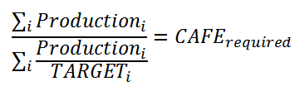

(Source: Centre for Climate and Energy solutions, 2014)

The downside of this approach is that the playfield is not level for large vehicle segments since compliance is easier for smaller ones. The standards were assessed by experts to have led to fuel savings of billions of barrels of oil over the years (Government Accountability Office, 2008).

With the support of the Obama administration, the US Environmental Protection Agency jointly with the National highway Traffic Safety administration has set fuel economy standards for 2017-2025 vehicles. Vehicles are classified on size basis for two broad categories: passenger cars and light trucks. Vehicle size (footprint) which is determined in a standardized way enters a formula that accounts as well for a manufacturer’s production or sales level. The standards are designed to accomplish a US fleet average fuel economy, by 2016, of at least 35.5 (GFEI, 2014). The target for 2025 is 54.5 mpg (New York Times, 2012). A shortcoming of those standards is restricting classifications of vehicles to size, which in light of the earlier discussion on the factors affecting energy efficiency of vehicles, is a factor among many.

## Driving Cycles

Implementation of fuel economy standards requires the enforcing agency to test the fuel economy or consumption figures presented model manufacturers. The applicable driving cycle should mimic typical driving patterns, behavior stops, accelerations, speed ranges with duration for each of urban and highway driving. For comparison across vehicles, a combined or overall fuel consumption or economy cycle is used, combining urban and highway cycles with different weightage according to the cycle’s location origin. In the United States the used driving cycle is called Corporate Average Fuel Economy (CAFÉ). In Europe, the used driving cycle is called New European Driving Cycle (NEDC).

For the driving cycles to be fully representative, they need extensive detailed data about characteristics of driving in locations where they are applied. Also, the vehicles used for designing the cycle must match the running models. Other factors, such as roads elevation, air and wind need to be accounted for. Some claim that manufacturers design vehicles to match the driving cycle at the destination market’s cycle, if there is one.

# Tunisia in North-African Context

Tunisia is a North-African/ Arab country that has a GDP of $ 1,083 billion at purchasing power parity, with an annual real economic growth rate of 2.3% in 2013 down from 3.6% in 2012 (CIA, 2014). Tunisia boasts a good level of GDP per capita at purchasing power parity, compared to other Middle-Eastern countries barring the oil importing ones. It figured to 9,500, 9,800 and 9,900 for 2011, 2012 and 2013, respectively (CIA, 2014).

Tunisia’s GINI index- a measure of income distribution within a country-is of around 36 in 2010, 40 in 2005, 40.8 in 2000, and 41.66 in 1985 (Quandl, 2014). Morocco, on the other hand, entertains a GINI index of more or less the same order of magnitude as Tunisia does, rounding up to 40 over the entire last decade, and a GDP per capita at purchasing power parity of $ 5, 500, $ 5300, $52200 in 2013, 2012 and 2011, respectively (CIA, 2014; Quandl, 2014).

The aforementioned figure should indicate, on being taken at face value, higher motorization rate in Tunisia than Morocco that was actually the case, for Tunisia had a rate of 121 and 124 per one thousand inhabitants for 2011 and 2012, respectively (OICA, 2012). On comparison, Morocco’s rate was 81 in 2011 and 84 in 2012 (OICA, 2012).

Egypt has a GINI coefficient that has been confined to an interval between 30 and 32 over the period from 1995 to 2008 (Quandl, 2014). That partly explains its lowest motorization rate among the said countries at 58 and 60 for the years 2011 and 2012 (OICA, 2012). That is despite the fact that it has GDP per capita levels higher than Morocco, remaining constant at $6,600 over the period from 2011 to 2013 (CIA, 2014).

Figures 1 shows the total number of cars on the road for Tunisia, Egypt and Morocco. Figure 2 shows the sales of new LDVs in Tunisia and Egypt for the years 2005, 2008, 2010 and 2012. Figure 3 shows the sales of new LDVs in Morocco for the years 2009, 2012 and 2013.

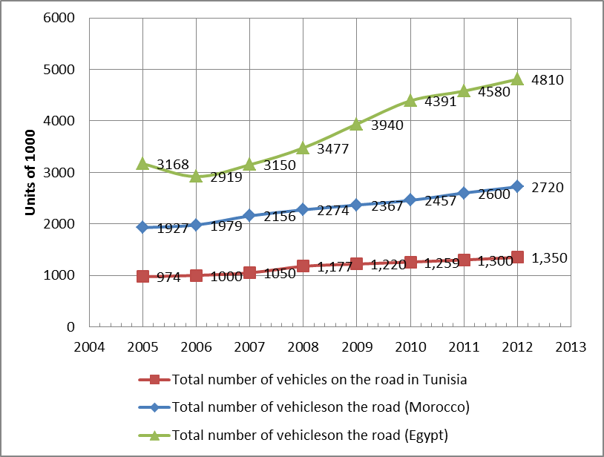

Figure 1: Total number of vehicles on the road. (OICA 2014)

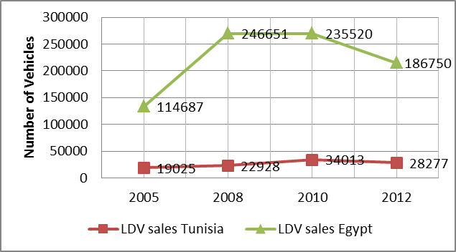.

Figure 2: Sales of new LDVs in Tunisia and Egypt (Matthias Gasnier, 2014)

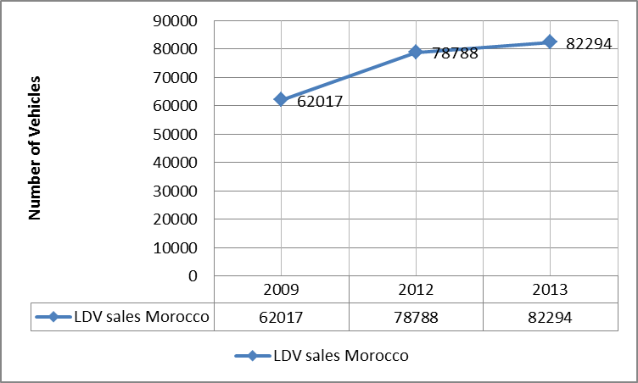

Figure 3: Sales of new LDVs in Morocco (Matthias Gasnier, 2014)

The total number of vehicles on the road reflects the difference in population sizes. Tunisia’s population has remained around 10 million since 2006; Morocco’s population has increased by about 2 million to around 32 million and Egypt by 12 million to around 82 million over the same period (Quandl, 2014). For Tunisia, total number of vehicles on the road has been relatively stable from 2005 till 2012, showing only a relatively slight increase from 974 thousand cars in 2005 to 1.35 million cars in 2012 (OICA, 2014). The Moroccan case showed a steady increase over the same period, though the rate of increase is lower than Egypt’s, especially over the period from 2005 till 2010. Figures 2 and 3 indicate that rate of increase of new LDV sales correlates with GDP growth fluctuations as Morocco witnessed a considerable increase in Purchasing Power Parity GDP between 2009 and 2012 (Quandl, 2014). The same goes for Egypt as sharp increases in sales of new LDVs sales over the period 2005-2008 correlated with record high GDP growth rates of 7.3 in the first quarter of 2008; whereas the plummeting sales from 2010 till 2012 correlated with a significant decrease in GDP growth rates in the aftermath of the Arab spring.

For Tunisia, the all but steady rate of increase of both total new cars on the road and new LDV sales indicate a lower average lifetime of cars in Tunisia compared to both Morocco and Egypt where the rate of increase in total vehicles on the road remains to a large extent independent of the sales of new LDVs.

Tunisia’s average GDP growth of 3.71 over the period from 2001 till 2014, which is close to both Morocco’s and Egypt, its higher GDP per capita and close GINI coefficients demonstrate that other variables are at play in the Tunisian case. Tunisia’s comparatively low population growth rates of 0.92% can only qualify as a partial explanation. The Tunisian trend therefore is attributed to factors inherent in the policy environment of the automotive sector which will be discussed in the following section.

# LDVs Policy Environment in Tunisia

The Tunisian automotive market has been heavily regulated by the government since 1995. The largest chunk of the market is taken by small cheap cars. Tunisian market is unique in the sense that the size of this portion, comprising all but the entire market except for a luxury cars niche, is completely determined by the government on annual basis (Focal Points, 2014). The quotas are determined by several factors. These are the country’s trade deficit, domestic demand and arrangements made between foreign automotive manufacturers and local car components manufacturers (US foreign commercial service, 2012). Those quota cars are termed in Tunisia “Shaabiyaa”, a word in Arabic which is close to popular. For those vehicles, most of the selected ones are small engine variants of popular models posing lesser technological sophistication than the ones in their countries of origin.

The tariff barriers in Tunisia are among the highest in the world and could reach up to 200%. Moreover, imported Shaabiyaa cars are liable to a 12 % VAT and a 3% customs formality fee (Meritas, 2013).

European manufacturers have the lion’s share of the Tunisian market with mainly French manufacturers in addition to Volkswagen. American, Japanese and Korean manufacturers have made incursions into the market (US commercial service, 2012).

Luxury and 4 by 4 cars are sold through authorized dealers though they are subject to very high consumption tax rates of 67% and 88% for petrol and diesel luxury cars, respectively ( US commercial service, 2012). They are not subject to the quota system, yet the handicapping rates confines luxury cars to a very small share of the market. Tax breaks are granted to cars owned by Tunisians abroad relocating to Tunisia, with the provision that they remain circulating within first degree relatives. Obtaining the exact figures for size of this alternative market is beyond the resources allocated to this report, yet it would be relaxingly on the safe side to state that it can never exceed 10% of the total vehicles market. Nonetheless, there are serious attempts on part of the Tunisian government to curb this market.

Vehicles franchise holders are pushing for increasing the quotas. There is also a detectable level of popular dissatisfaction with the quota system since Tunisia’s indicators discussed in the previous chapters fare very well in comparison to Morocco and Egypt albeit the diversity in their markets are much higher with more abundance of upmarket vehicles. Macroeconomic considerations weigh on government’s decisions in that regard. The higher level of urbanization compared to other North African countries and the relative abundance of public transportation help curtail popular criticism of the existing policies.

# 

# Data for CO2 Emissions and Fuel consumption in Tunisia

Figure 4 shows the evolution of LDVs CO2 emissions in Tunisia for the years 2005, 2008, 2010 and 2012. The weighted average was calculated according to the GFEI methodology. Also, unweight average CO2 emissions for LDVs was calculated for the same years. The unweight average discounts the impact of sales figures for different models.

Figure 4: Different averages for co2 emissions in Tunisia

Petrol LDVs weighted average remained steady at approximately 134 gco2/km levels for 2005, 2008 and 2010 then it declined to 132 gco2/km in 2012. Average CO2 emissions, on the other hand, remained almost constant for 2005 and 2008 at 149.6 gco2/km and 150 gco2/km, respectively. It increased to 147.2 gco2/km in 2010 then dropped to 145 gco2/km in 2012.

Combined weighted average for petrol & diesel LDVs had always been higher for the same period though it followed the same pattern of petrol LDVs. This is due to the impact of CO2 emissions from diesel LDVs as shown in Figure 5.

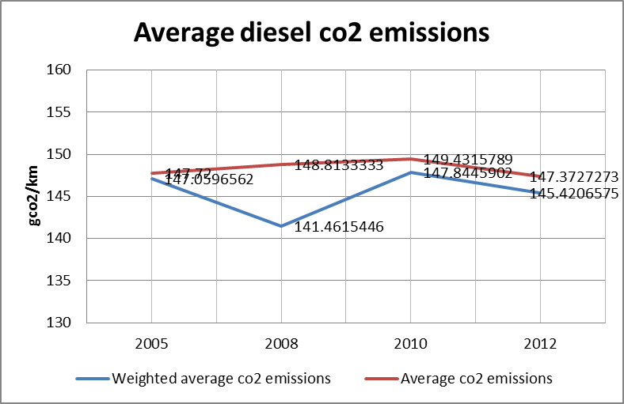

Figure 5: Different averages for diesel CO2 emissions in Tunisia

Weighted average CO2 emissions for diesel LDVs had remained always higher than petrol ones at 147 gco2/km and 141 gco2/km for the years 2005 and 2008, respectively. In 2010 they increased again to 147 gco2/km, only to drop in 2012 to 145 gco2/km.

Average diesel LDV CO2 emissions were lower than petrol’s for the years 2005 and 2008 at 147 gco2/km and 148 gco2/km, respectively. However, in 2010 and 2012 they exceeded petrol’s with 149 gco2/km in 2010 and 147 in 2012. Average CO2 emissions were higher than weighted ones for all the years.

***Fuel Consumption Trends***

Figure 6 shows fuel consumption (L/100km) trends for petrol LDVs in Tunisia for the years 2005, 2008, 2010 and 2012**.**

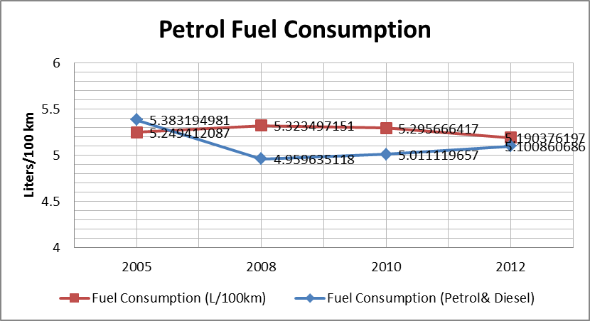

Figure 6: Petrol fuel consumption for LDVs in Tunisia

The figures for weighted average fuel consumption remained approximately steady for 2005, 2008, 2010 and 2012 at 5.2, 5.3, 5.2, and 5.1, respectively. Figure 7 shows the aforementioned trend for diesel vehicles.

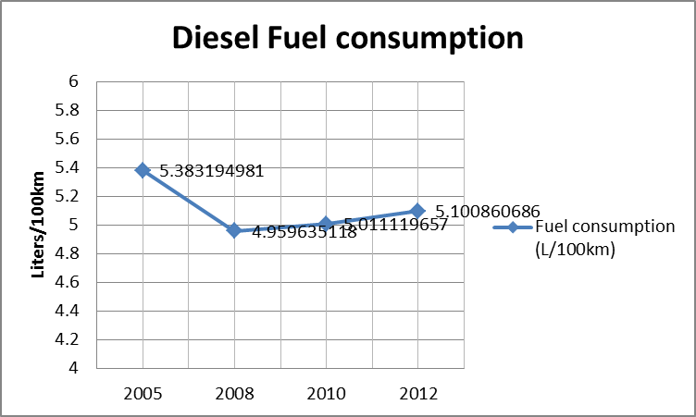

Figure 7: Diesel fuel consumption for LDVs in Tunisia

Weighted average fuel economy for diesel LDVs had remained constant at almost 5 gco2/km for 2008, 2010 and 2012. In 2005, the weighted average was bit higher at 5.3 gco2/km. Table 2 shows the average engine size in liters for petrol and diesel LDVs for the years 2005, 2008, 2010 and 2012.

Table 2: Average engine sizes for diesel and petrol LDVs in Tunisia

|  |  |  |  |  |
| --- | --- | --- | --- | --- |
| **Year** | **2005** | **2008** | **2010** | **2012** |
| **Average engine size in liters (petrol)** | 1.4 | 1.4 | 1.4 | 1.4 |
| **Average engine size in liters(diesel)** | 1.9 | 1.9 | 2 | 2 |
| **Mode engine size in liters (petrol)** | 1.2 | 1.4 | 1.4 | 1.6 |
| **Mode engine size in liters (diesel)** | 2 | 2 | 2 | 2 |

# Discussion of Data

Non-OECD fuel economy averages for LDVs in L/100km for 2005, 2008 and 2011 were 7.5, 7.6, 7.5, while OECD averages were 8.1, 7.6 and 7 (Fuel Economy State of the World, 2014). Tunisia fared very well in comparison with the two said groups, with fuel consumption levels well below their averages at few decimal points above and below 5 l/km for both petrol and diesel LDVs. This is more by accident than design since the criteria for allocating quotas do not account specifically for fuel consumption or CO2 emissions.

For petrol LDVs, CO2 emissions rates followed the same pattern of change of fuel consumption for the study years since there is a strong causation between fuel consumption and CO2 emissions. All the same, the patterns of increase and decrease for CO2 emissions were more fleshed out than those for fuel consumption. This is because a slight change in fuel consumption is associated with a much larger one for CO2 emissions.

For diesel LDVs, CO2 emissions rates followed the same pattern of change of fuel consumption for 2005, 2008 and 2012. However, for the year 2012 fuel consumption increased by a few decimal points while CO2 decreased. This could be explained by the wider variety of vehicles sold in Tunisia in 2012 where fuel consumption and CO2 emissions empirical relations had exhibited different forms of non-linearity.

Fuel consumption of diesel LDVS had been close to petrol for the same study period despite the use of larger diesel LDVs with larger engine sizes. Main reason is that diesel engines show better fuel consumption than petrol ones unless the characteristic is offset by vehicle features such as a much larger engine size or body weight. CO2 emissionsfor diesel LDVs had been consistently larger than those of petrol ones due the higher carbon content of diesel.

Diesel LDVs sales comprised mainly pick-ups/mini-vans, 4 by 4 cars and other large cars. This is indeed a sound regulation due the better fuel consumption of diesel LDVs thus saving considerable barrels of fuel in absolute terms.

For petrol LDVs the CO2 unweight average curve had been consistently higher than weighted average one. This shows the availability of an ample room for improving CO2 emissions and the concomitant fuel consumption rates by pulling the unweight average curve down closer to the weighted average one through a models selection criteria accounting for fuel consumption considerations.

For diesel LDVs however the weighted average curve had always been above the unweight ones. This is mainly due the large sales of the fuel efficient Renault symbol, and of pick-ups and mini-vans, while the rest of diesel sales are of a wider variety of luxury upmarket models, which in turn raised the unweight average.

***Year 2005***

Renault symbol, Volkswagen Polo, Peugeot 206, Fiat Punto, Volkswagen Passat and Ford Fiesta accounted for 83.9% of total sales of new petrol LDVs through authorized dealers. Their fuel consumption levels in l/100km were 5.9, 3.9, 6.4, 5.7, 4.9, and 5.8. All well below both the OECD and non-OECD average.

For diesel LDVs, Renault symbol, Peugeot Partner and Citroen Berlingo accounted for most of sales with the Berlingo and Symbol being of the pick-up/ mini-van segment. This explains why fuel consumption for diesel LDVs was slightly higher than petrol’s. The large number of sales of diesel Renault Symbol prevented the diesel fuel consumption level from shooting up.

***Year 2008***

Renault symbol, Volkswagen Polo, Peugeot 206, Fiat Punto, Volkswagen Passat and Ford Fiesta accounted for 80% of total sales of new petrol LDVs through authorized dealers. Fuel consumption for those years has not changed, yet their sales increased and their share of total LDV sales slightly decreased, explaining the slight increase in fuel consumption from 5.2 l/100 km to 5.3 l/100 km.

For diesel LDVs, sales of Citroen Berlingo and Peugeot partner remained almost the same. However, Renault symbol sales increased in addition to increased sales of Citroen C4 which has a fuel consumption of 4.5 l/100km, which explains the drop in fuel consumption by several decimal points from 5.3 l/100 km to 4.9 l/100 km.

***Year 2010***

Renault symbol, Volkswagen Polo, Kia Rio, Ford Fiesta, Peugeot 206, Volkswagen Golf, Fiat Punto, Volkswagen Passat, Kia Picanto accounted for 75% of total sales for new petrol LDVs through authorized dealers. Most of them had fuel consumption levels slightly lower than those for the previous years. The weighted fuel economy average therefore had remained the same with a slight decrease of a few decimal points.

For diesel LDVs, fuel consumption remained almost the same as that for 2008.

***Year 2012***

Renault Symbol, VW Polo, Kia Rio, Ford Fiesta, Fiat Punto, Peugeot 206, VW Golf, Chevrolet Aveo, Citroen C3 and Seat Ibiza accounted for 76% of total sales for new petrol LDVs through authorized dealers. Fuel consumption decreased by a 0.1 decimal point. Obviously that was not a tangible increase though it could be attributed to a relatively wider variety of more efficient LDVs accompanied by a slight decrease in the market share of the aforementioned models which had retained the largest chunk by far of the Tunisian market throughout the years trended in the present report.

Renault Symbol, Peugeot Partner, Citroen C4 and Ciroen Berlingo made up most of diesel LDVs sales in Tunisia for the year 2012. Fuel consumption increased marginally by a decimal point due a wider variety of models in 2012.

# Way Forward

For the years trended in the report, Tunisia managed to maintain outstanding fuel consumption rates on a weighted average scale. This should somewhat run counter to what might have been expected from a North African country achieving high motorization rates and boasting sound economic indicators in a comparative perspective. The quota regulation of the petrol Shaabiyaa vehicles is the main source of this desired trend. As discussed earlier in the report, macroeconomic considerations and boosting domestic industry are the pivotal tenets of quota allocation.

The selected models show an overwhelming preference for cheap European vehicles thus capitalizing inadvertently on the increasingly tightening fuel consumption regulation of European manufacturers. Further, in many cases the variant design is tweaked to suit markets with significant taxation and tariff barriers. This is carried out through offering a variant for a certain model with a scaled back engine size. On the downside, the petrol model variants selected for the Tunisian market entertain less sophisticated technological capabilities than their European counterparts.

On absolute terms, the motor petrol consumption in Tunisia had been on the rise since 2006 as shown by Figure 8.

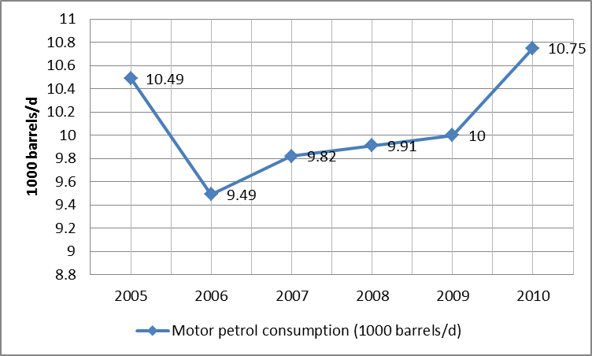

Figure 8: Evolution of motor petrol consumption in Tunisia (The globaleconomy.com, 2014)

The discussion in previous sections demonstrates that the current quota system is indeed not the best available design as far as petrol consumption is concerned. The fact that Tunisia does not hold sizeable oil reserves and that its refining industry only supplies a part of its domestic demand highlights the importance of curbing fuel consumption; an issue that should be pushed to the fore of national agendas. It is worth mentioning that the noticeable drop in petrol consumption in 2006 can be attributed to the 2006 8.9% increase in fuel prices reported by the OECD (2014). In Tunisia, fuel consumption in absolute terms is affected considerably by fuel prices due to the widespread public transportation in comparison to other Middle-Eastern countries. Above ground metro fully covers Tunis the capital and some other cities. Other cities enjoy wide coverage of both public and private bus networks that cater to the needs of different societal segments. In the industrial city of Sfax motorbikes are a common incidence among both male and female commuters.

4 by 4 LDVs and many other luxury ones run on the energy efficient diesel fuel, where a retail infrastructure supports this portion that lies outside the quota system, indicating a sound policy decision on part of the Tunisian government. It also points to the presence, among Tunisian LDVs owners, of a level of fuel-efficiency consciousness.

The existing room for fuel consumption improvement discussed earlier meets with a salient need for Tunisia to limit as much as possible the levels of fuel consumption in absolute terms. That Tunisia relies for the most part on imports for satisfying its domestic demand on refined oil products accentuate the importance of that need. Some of the GFEI fuel economy policy instruments are already partially in effect in Tunisia. The policy environment is therefore set for designed improvement in fuel consumption via integrating fuel criteria into the existing import restrictions and vehicle taxation and duties instruments.

The stepping stone to meeting the goal of accruing fuel savings is the introduction of locally tailored fuel consumption/economy standards linked to specified targets for curbing the year by year increasing number of LDVs on the road and confining motor fuel consumption to sustainable levels. The standards must be integrated into wider state-level plans for sustainable growth; maintaining and enhancing the green image of Tunisia in the region; curbing trade deficits, and promoting social harmony.

The flourishing civil society in the aftermath of the Jasmine revolution inserts another variable that has to be dealt with, that is the increased democratization of Tunisia where popular demands must be adequately addressed. In that context, enhancing the availability and sustainability of the transportation sector should act as a stabilizing condition that could create a win-win situation vis-à-vis the popular demands for going upmarket as regards the LDVs models available in Tunisia.

Developing effective fuel economy/consumption standards must be viewed as a vehicle towards the attainment of the aforementioned goals and hence they must be crafted in line with the particular Tunisian case. Enabling conditions in terms of the presence of a fuel economy/consumption favorable policy environment poke the starting point of standards development a few steps up the ladder. Further, something akin to a fuel consumption/efficiency criteria is in Tunisia as it is since Tunisian regulators laid the ground for an increasing share of the more fuel efficient diesel LDVs when it comes to the luxury market segment.

The point of departure must be the development of local Tunisian driving cycle since the driving patterns and behavior, commuting distances, road topography are significantly different from those upon which the New European Driving Cycle and the American CAFÉ are based. The point is to ensure that testing the manufacturers’ fuel economy/consumption data match Tunisian driving, and to circumvent errors in estimations of actual fuel savings that arise from inconsistencies between manufactured labeled fuel consumption/economy and actual figures.

Tunisia has no automotive manufacturing industry- barring automotive components manufacturing for European car makers. Lacking an automotive industry can be turned into quite an advantage when it comes to fuel consumption/economy standards. One reason is the absence of political leverage wielded by the automotive industry in other places, which puts limits on the design of fuel consumption/economy standards. Another is the opportunity to learn from the shortcomings of standards applied elsewhere.

A more effective approach, which could be suitable for the Tunisian case, would be basing the standards’ classification on a host of factors of which the prime ones are the technological attributes of the engine, discussed in previous sections, along with total mass and other factors. Relative weights can be assigned to each factor.

Applying fuel consumption/economy standards might lead to increased prices of quota cars due to opting for more technologically sophisticated variants and models with ensued increases in prices-albeit it could partly stem some of the consumers’ dissatisfaction with the current quota system. Tunisia has made strides in the introduction of high quality fuels, eliminating a potential barrier to the introduction of LDVs with more efficient technologies.

The increased burden on trade balance can be offset by savings in fuel imports, provided that standards are deftly crafted in connection with identifiable savings in fuel consumption relative to way things presently are. Hence a holistic scenario tackling political, trade and local industry aspects related to the application of fuel consumption/efficiency standards must be set. It should accommodate plans for sustainable transportation and consumers’ satisfaction.

***Recommendations for Fuel economy/consumption standards in Tunisia***

* **The establishment of a multi-stakeholder resident committee at the ministry of energy or trade.** The committee must include representatives from domestic automotive components industry, the national statistics agency, and high caliber international fuel markets experts, trade and energy policy makers, technical automotive engineers, and automotive markets consultants. The committee should be assigned the task of preparing a roadmap for the preparation and introduction of fuel consumption/economy standards.
* **Drawing on international experience and expertise.** The GFEI has accumulated a wealth of technical and planning experiences with respect to fuel consumption/efficiency standards, their implementation, and impacts**.** It is therefore the entity best equipped and resourced to support the abovementioned resident committee in materializing the roadmap into a comprehensive action plan for developing, implementing fuel consumption/economy standards serving towards the end of curbing Tunisian fuel consumption in absolute terms. It should play a consultative role starting from the inception phase of the resident committee. This starts by determining the data gaps and the required studies for arriving at accurate information about driving patterns and behaviors, commute distances at an encompassing national level. Second, the GFEI should support the establishment of different scenarios for fuel consumption/economy standards, ones that account for urban expansion and transportation plans, political sensitivities, business and macroeconomic considerations.

**References List**

* Center for Climate and Energy Solutions (C2ES). (2014). Federal Vehicles Standards. Available at: <http://www.c2es.org/federal/executive/vehicle-standards>. Accessed: September 10th, 2014.
* Central Intelligence Agency: Tunisia (2014). Available at: <https://www.cia.gov/library/publications/the-world-factbook/geos/ts.html>. Accessed: July 29th, 2014.
* Central Intelligence Agency: Morocco (2014). Available at: <https://www.cia.gov/library/publications/the-world-factbook/geos/mo.html>. Accessed: August 3rd, 2014
* Central Intelligence Agency: Egypt (2014). Available at: <https://www.cia.gov/library/publications/the-world-factbook/geos/mo.html>. August 5th, 2014.
* Chiaberge, Marcello (2011). *New Trends and Developments in Automotive System Engineering.* Intech: Rejeka.
* Global Fuel Economy Initiative, 2013. Global Fuel Economy Initiative: 50by50. http://www.globalfueleconomy.org/about/Pages/AboutHome.aspx. Accessed: September 8th, 2014.
* Global Fuel Economy Initiative: GFEI (2014). Available at: <http://www.unep.org/transport/gfei/autotool/nextsteps/developing_a_baseline.asp>. Accessed: August 19th, 2014
* Global Fuel Economy Initiative: GFEI (2014). The European Union Automotive Fuel Economy policy. Available at: <http://www.unep.org/transport/gfei/autotool/case_studies/europe/cs_eu_0.asp>. Accessed September 11th,2014
* Global Fuel Economy Initiative: GFEI (2014). The US Automotive Fuel Economy policy. Available at: <http://www.unep.org/transport/gfei/autotool/case_studies/northamerica/cs_us_0.asp>. Accessed: September 14th, 2014.
* Institute of Mechanical Engineering (2011). Internal Combustion Engines: *Improving Performance, Fuel Economy and Emissions*. Woodhead Publishing Limited: London
* Meritas: Law Firms worldwide (2013). Available at: <http://www.meritas.org/emea_tax/march-2013-tunisia.htm>. Accessed: September 5th, 2014
* Parry, Ian. Anderson, Soren. Sallee, James M. Fischer, Carolyn. (2010). *Automobile Fuel Economy Standards: Impacts, Efficiency, and Alternatives*. Resources for the Future: Washington, DC.
* Quandl (2014). Egypt GINI index. Available at: <https://www.quandl.com/WORLDBANK/EGY_SI_POV_GINI-Egypt-Arab-Rep-GINI-index>. Accessed: September 18th, 2014.
* Quandl (2014). Egypt population data. Available at: <https://www.quandl.com/UN/DEV_POPULATIONTOTAL_EGY-Population-Total-Egypt>. Accessed: September 20th, 2014.
* Quandl (2014).Morocco GINI index. Available at: <https://www.quandl.com/WORLDBANK/MAR_SI_POV_GINI-Morocco-GINI-index>. Accessed: September 18th,2014
* Quandl (2014) Morocco Population data. Available at: <https://www.quandl.com/UN/DEV_POPULATIONTOTAL_MAR-Population-Total-Morocco>. Accessed: September 20th, 2014.
* Quandl (2014). Tunisia GINI index. Available at: <https://www.quandl.com/WORLDBANK/TUN_SI_POV_GINI-Tunisia-GINI-index>. Accessed: September 18th, `2014.
* Quandl (2014). Tunisia Population data. Available at: https://www.quandl.com/UN/DEV\_POPULATIONTOTAL\_TUN-Population-Total-Tunisia. Accessed: September 20th, 2014.
* Stone, Richard (1992). *Introduction to Internal Combustion Engines.* 2nd edition. The Macmillan Press Limited: London.
* The globaleconomy.com (2014). Tunisia Gasoline Consumption. Available at: <http://www.theglobaleconomy.com/Tunisia/gasoline_consumption/>. Accessed: September 25th, 2014.
* The Organization for Economic Cooperation and Development (OECD). (2007). African Economic Outlook: Tunisia. Available at: <http://www.oecd.org/dev/emea/africaneconomicoutlook2007.htm>. Accessed: September 17th, 2014.
* United States of America. Government Accountability office (2008). *Vehicle Fuel Economy.* New York: Novinka books.
* United States of America.US Foreign Commercial service and US Department of State (2012).*Doing Business in Tunisia*. Washington, DC.

1. **FIA Foundation, International Energy Agency (IEA), International Transport Forum (ITF), United Nations Environment Programme (UNEP), and the International Council on Clean Transportation (ICCT).** [↑](#footnote-ref-1)